Course Methods Year 12 test three 2022

Student name: ________________ Teacher name: ________________

Task type: Response

Time allowed for this task: _____40______ mins

Number of questions: ____6_______

Materials required: Upto 3 calculators/classpads allowed

Standard items: Pens (blue/black preferred), pencils (including coloured), sharpener, correction fluid/tape, eraser, ruler, highlighters

Special items: Drawing instruments, templates, one page of A4 notes doublesided

Marks available: ___43___ marks

Task weighting: _10___%

Formula sheet provided: Yes

Note: All part questions worth more than 2 marks require working to obtain full marks.

Q1 (3, 3 & 2 = 8 marks) (3.3.1)
Consider the discrete random variable and the table of probabilities below.

 | 0 | 1 | 2 | 3 | 4
 | 0.2 |  | 0.3 |  | 0.25

- Given that the expected value of is 2.15, determine the values of .

- Determine the standard deviation of to 3 dp, showing all reasoning.

- Determine the and Variance().

Q2 (3, 2, 1 & 3 = 9 marks) (3.3.3)

The number of minutes late a train arrives at a particular station is a uniform probability distribution from 5 mins to 25 mins.
- Sketch the probability density function for showing all relevant features and labels.

Q2 continued
- Determine the probability that the train will be less than 12 mins late given that it is at least 7 mins late.

- Determine the mean number of minutes late.

- Determine the standard deviation of showing all reasoning.

Q3 (3, 3 & 2 = 8 marks) (3.3.1)
Consider a game where two ordinary dice are thrown into the air and then land and the sum of the two top numbers is added. If the sum is a prime number etc then this is considered a win.

- Determine the probability of a win. Show reasoning.

- If this game was played 10 times, determine the probability that a win occurs at least 7 times. Show all reasoning.

Q3 cont-
- Let = sum of the top numbers of both dice. Determine the mean and standard deviation for .

Q4) (5 marks) (4.1.6)
Consider where are constants.
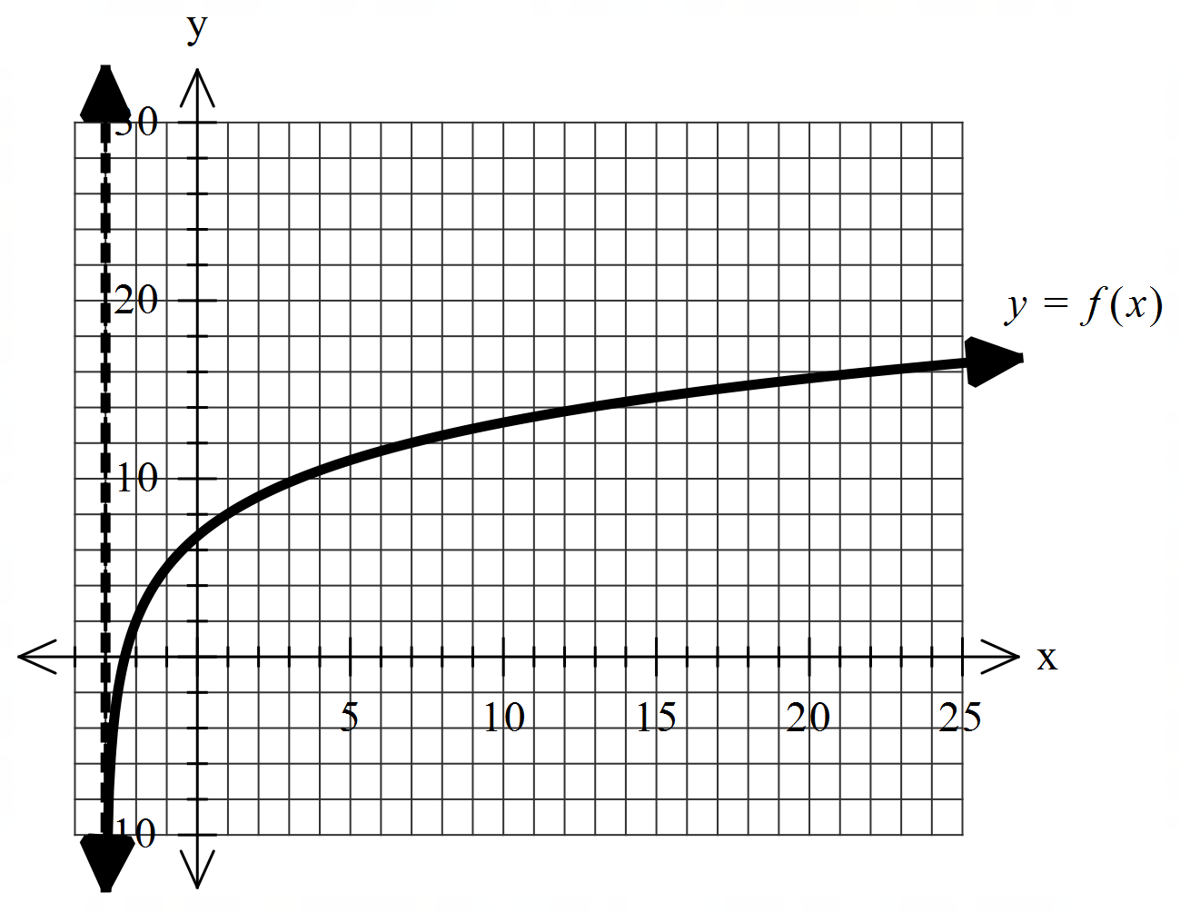

Using the graph above and given that the following points
lie on the curve , determine the values of .

Q5 (2, 2 & 2 = 6 marks) (4.2.2)
Consider the probability density function and zero for all other values
of .
- Show that .

- Determine the probability for the above function.

- Determine the median.

Q6 (2 & 5 = 7 marks) (4.1.11)

- Show without the use of a classpad how to .

Continued on next page for Q6b
- Using (a) above and without the use of a classpad, show how to evaluate .

Hint-use

Q6 continued

